INFORMATION TECHNOLOGY

CANSA ASSOCIATION



PHASE 1.2

|  |
| --- |
| **CONTENTS** |

|  |  |
| --- | --- |
|  | **PAGES** |
| 1. GUI Design | 2 - 4 |
| 1. Flowchart | 5-6 |
| 1. Data Dictionary | 7-8 |
| 1. Software Design | 9-12 |
| * Data Input |
| * Validation |
| * Data Processing |
| * Data Output |

|  |
| --- |
| **GUI DESIGN** |

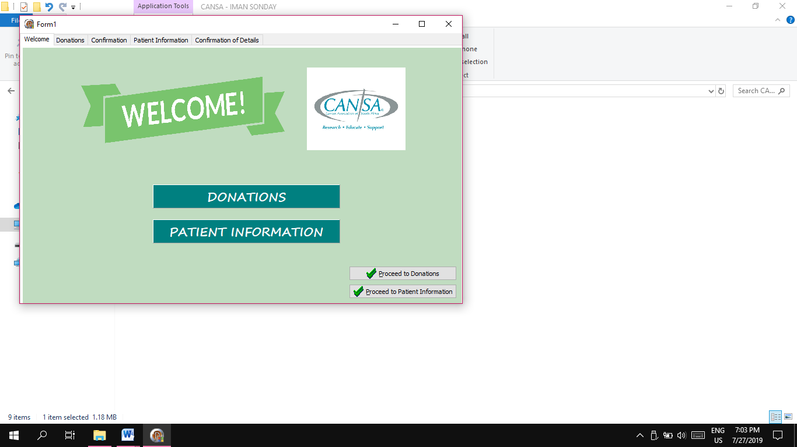

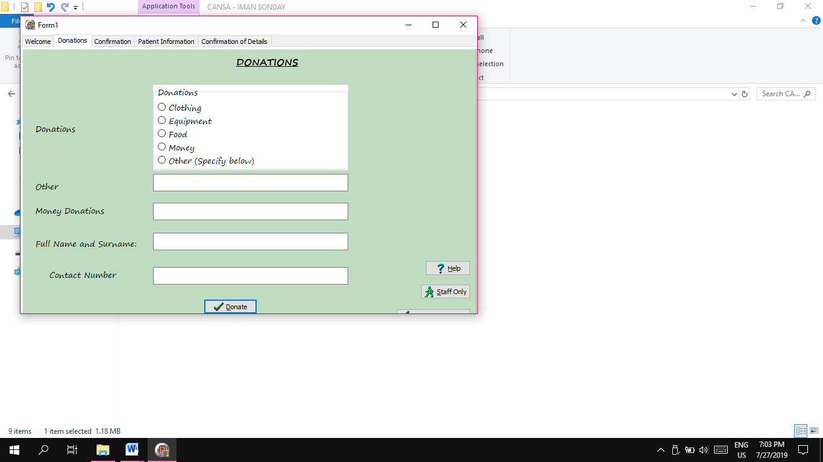

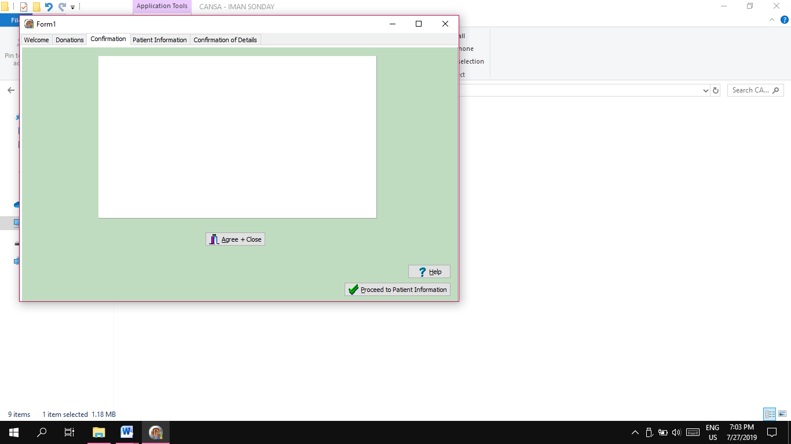

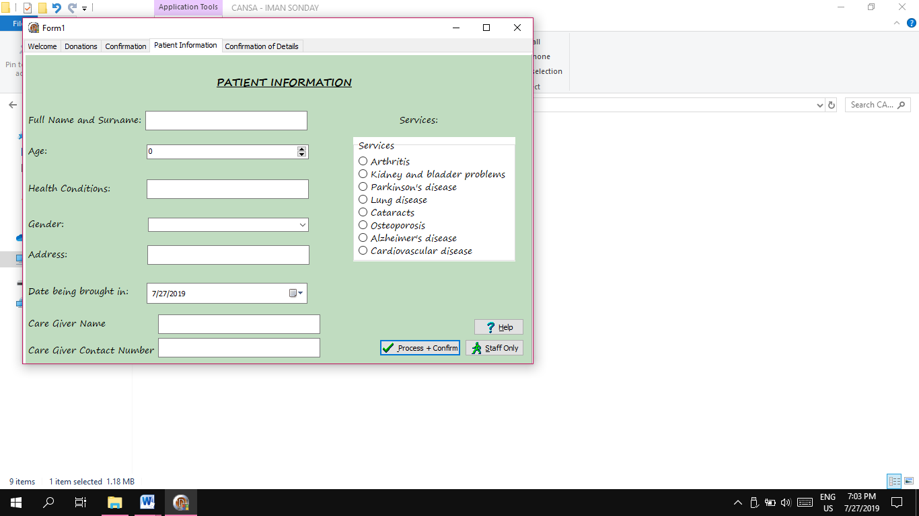

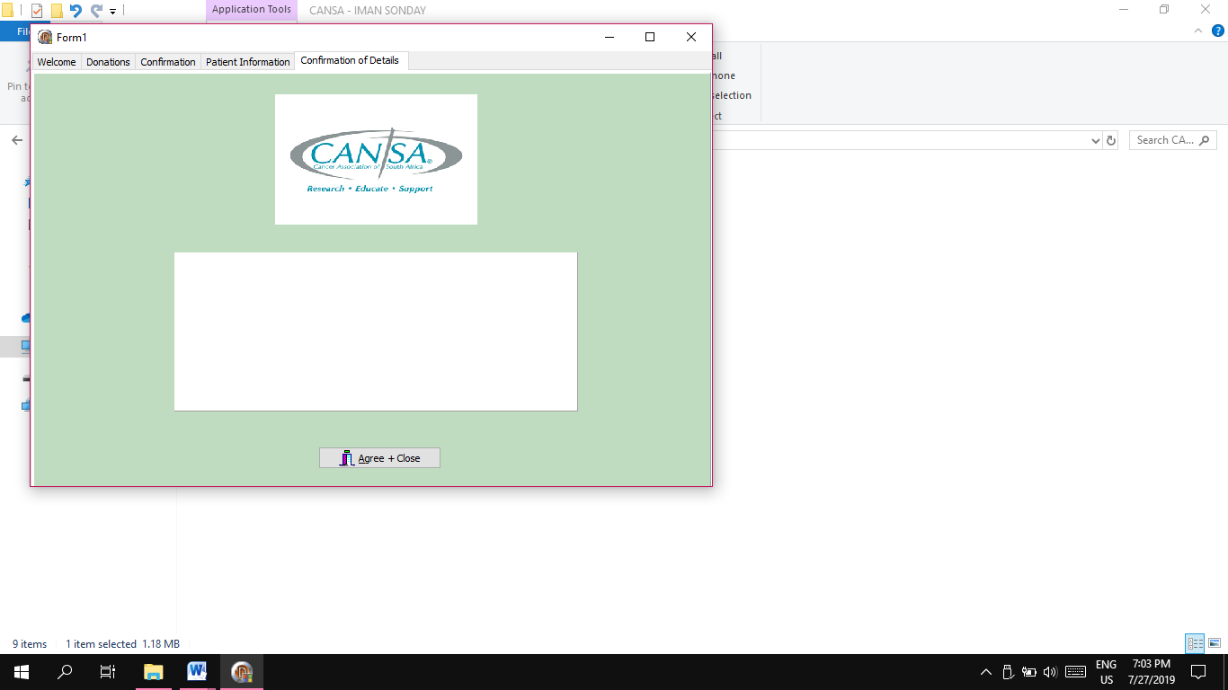

|  |
| --- |
| **Flowchart** |

**START**

Proceed to Donations

Proceed to Patient’s Information

Get user’s full name and surname

Get type of Donations

Get other Type of Donations

Get user’s Age

Get money donations amount

Get the user’s Health conditions

Get the user’s gender

Get donator’s full name and surname

Get donator’s contact number

Get user’s address

Is all the required fields entered?

Get the date the patient will be admitted

Get the services the patient should receive

**YES**

**NO**

Process information

Staff access through a code

Show Help

Get the patient’s ID Number

Get the care giver’s name and surname

Specify whether the patient is a pensioner or not

Close

**YES**

**NO**

**YES**

Get the care giver’s name and surname

Output details

Are all details correct?

Get the care giver’s contact number

Go back to the donations Tab

Are all the details correct?

Proceed confirmation

Is all the required fields entered?

**End**

Close

**YES**

Fill in all required fields

Proceed to staff access

**NO**

|  |
| --- |
| **DATA DICTIONARY** |

|  |  |  |  |  |
| --- | --- | --- | --- | --- |
| **Type** | **Variable** | **Use** | **Data Type** | **Scope** |
| **Tab Sheet 2 - Donations** | | | | |
| **TEdits** | sOther | Get information from the user | String | Local |
| rMoneyDonations | String (stores Real Values) | Constant  +  Local |
| sDonatorNameSurname | String | Global |
| **RadioGroup** | rgpDonations | Options of donations the user can choose from | Items | Local |
| **Tab Sheet 3 - Confirmation** | | | | |
| **TPanel** | pnlDonationConfirmation | Contains and stores all information the user had entered in the donations tab | String | Local |
| **Tab Sheet 4 - patient Information** | | | | |
| **TEdits** | sPatientNameSurname | Get and store the patients name and surname | String | Global |
|  | sHealthConditions  sAddress  sCareGiverName | Get and store the users health conditions, address,caregivers name | Strings | Local |
|  | iGiverNumber | Get and store the caregivers contact number | Integer | Local |
| **SpinEdits** | iAge | The patients age | Integer | Local |
| **ComboBox** | Gender | To specify whether the patient is a male or female | Boolean | Local |
| **TDateandTime** | Date | The date the patient will be brought in | TDate | Local |
| **RadioGroup** | rgpServices | Options of services the user can choose from | Items | Local |

|  |  |  |  |  |
| --- | --- | --- | --- | --- |
| **Tab sheet 5 - Confirmation** | | | | |
| **TPanel** | pnlPatientConfirmation | Displays all information the user entered in the patient information tab so that they can confirm all details | String | Local |

**Data Types used:**

* Strings
* TDate
* Integer
* Real
* Boolean
* Char

**Constant**: Money Donation (Least amount = R50 + if user wants to give more)

**Global**: sPatientNameSurname + sDonatorNameSurname

|  |
| --- |
| **SOFTWARE DESIGN TOOL - IPO** |

**DATA INPUT:**

|  |  |  |
| --- | --- | --- |
| **INPUT** | **DATA TYPE** | **SOURCE** |
| **TAB SHEET 2 - DONATIONS** | | |
| Any other donations that is not listed in the options given, the user is asked to enter it | String | Keyboard entry |
| The user can also give a donation in the form of money which they are asked to enter the correct figure | String (stores Real Values) | Keyboard entry |
| The user is asked to enter their name and surname which will be stored in the variable sNameSurname | String | Keyboard entry |
| The user is given options of donations to choose from | Items | Mouse click |
| **TAB SHEET 4 - PATIENT INFORMATION** | | |
| The Patients name should be entered in the edtNameSurname | String | Keyboard entry |
| The patients chronic health conditions should also be listed | String | Keyboard entry |
| The physical address of the patient | String | Keyboard entry |
| The care giver of the patients details should also be entered in case of an emergency | String | Keyboard entry |
| The patients age that can be chosen from the list of ages (from the spinEdit) | Integer | Selection |
| The patients gender can be chosen from the two options listed in the combo Box | Boolean | Selection |
| The user can choose the date the patient wishes to be admitted | TDate | Mouse click |
| Whether the patient is a pensioner or not should be stated | Character | Mouse click |

|  |  |  |
| --- | --- | --- |
| The services the patient wishes to get can be chosen from the radio group’s list of options | Items | Selection |

**VALIDATION**

|  |  |  |
| --- | --- | --- |
| **WHAT WILL BE VALIDATED** | **ALGORITHM** | **MESSAGE** |
| **TAB SHEET 2 - DONATIONS** | | |
| **btnDonate** | Ask ”Is all required Fields entered?”  BEGIN  sOtherDonations:=edtOtherDonations.text;  iMoneyDonations:=IntToStr(edtMoneyDonations.text);  iDonatorNumber:=IntToStr(edtNumber.text);  Flag1:= sOtherDonations=’ ‘ OR  IMoneyDonations = ‘ ‘ OR  IDonatorNumber = ‘ ‘ OR DonatorNameSurname = ’ ‘;  if Flag1 then  showmessage: (‘Please enter all required fields’)  END | If all required fields are not entered display message: “Please enter all required fields!” |
| **TAB SHEET 4 - PATIENT INFORMATION** | | |
| **btnProcess** | Ask ”Is all required Fields entered?”  BEGIN  iAge:=sedAge.value;  sHealthConditions:=edtHeathConditions.text;  sAddress:=edtAddress.text;  sCareGiverName:=edtCareGiverName.text;  sCareGiverNumber:=edtCareGiverNumber.text;  sID:=IntToStr(edtIdNumber.text);  Flag1:= iAge=’ ‘ OR  sHealthConditions= ‘ ‘ OR  sAddress= ‘ ‘ OR sCareGiverNumber= ’ ‘;OR sID = ’ ‘OR sPatientName= ’ ‘OR cmbGender = ’ ‘ OR PatientNameSurname=’ ‘;  if Flag1 then  showmessage: (‘Please enter all required fields’)  END | If all required fields are not entered display message: “Please enter all required fields!” |

**DATA PROCESSING**

|  |  |
| --- | --- |
| **WHAT WILL BE PROCESSED** | **ALGORITHMS** |
| **TAB SHEET 2 - DONATIONS** | | |
| All the data that is entered relating to the donations will be stored and be visible in a later stage | BEGIN  sAllDonationInformation:= ‘CONFIRMATION OF DETAILS’ + ’Donator Name & Surname: ‘ + DonatorNameSurname + #13 + ‘Donator Contact Number: ‘ + iDonatorNumber +#13 +rgpDonations.Items(ItemIndex)+#13+’Other Donations: ‘ + sOtherDonations + #13 + ‘Money Donations: ’ + iMoneyDonations +#13 + ‘ -----------------------------------‘;  END | |
| **TAB SHEET 4 - PATIENT INFORMATION** | | |
| All the data that is entered relating to the patients Information will be stored | BEGIN  sAllPatientsInformation:= ‘CONFIRMATION OF DETAILS’ +#13+ Patient Name & Surname: ‘ + PatientNameSurname + #13+’Gender: ‘ +cmbGender.text+#13+ ’Age: ‘ + iAge#13+’Health Conditions: ‘ +  sHealthConditions+#13+’Address: ‘+  sAddress+ #13+ ‘Care Giver Name: ‘ +sCareGiverNameSurname+#13+’Patient ID: ‘ + sID +#13+ ‘Care Giver Number: ‘+sCareGiverNumber+#13 + ‘ -----------------------------------‘;  END | |

**DATA OUTPUT**

|  |  |  |
| --- | --- | --- |
| **WHAT WILL BE DISPLAYED** | **FORMAT** | **OBJECT** |
| **TAB SHEET 3 - DONATIONS CONFIRMATION** | | |
| All the information gathered from when the user entered their details in the required fields from the Donations Tab will be displayed in the pnlDonationConfirmation so that the user can confirm the details | BEGIN pnlDonationConfirmation .caption :=sAllDonatorInformation;  END | pnlDonationConfirmation |
| **TAB SHEET 5 - CONFIRMATION** | | |
| All the information gathered from when the user entered their details in the required fields from the Patient Information Tab will be displayed in the pnlPatientConfirmation so that the user can confirm the details | BEGIN pnlPatientConfirmation.caption :=sAllPatientInformation;  END | pnlPatientConfirmation |